Functional Requirements:

1. The system shall allow the user to add an event to the calendar
   1. The system will display multiple calendar options upon selecting the button identified as “Calendar Options” at the bottom of the screen.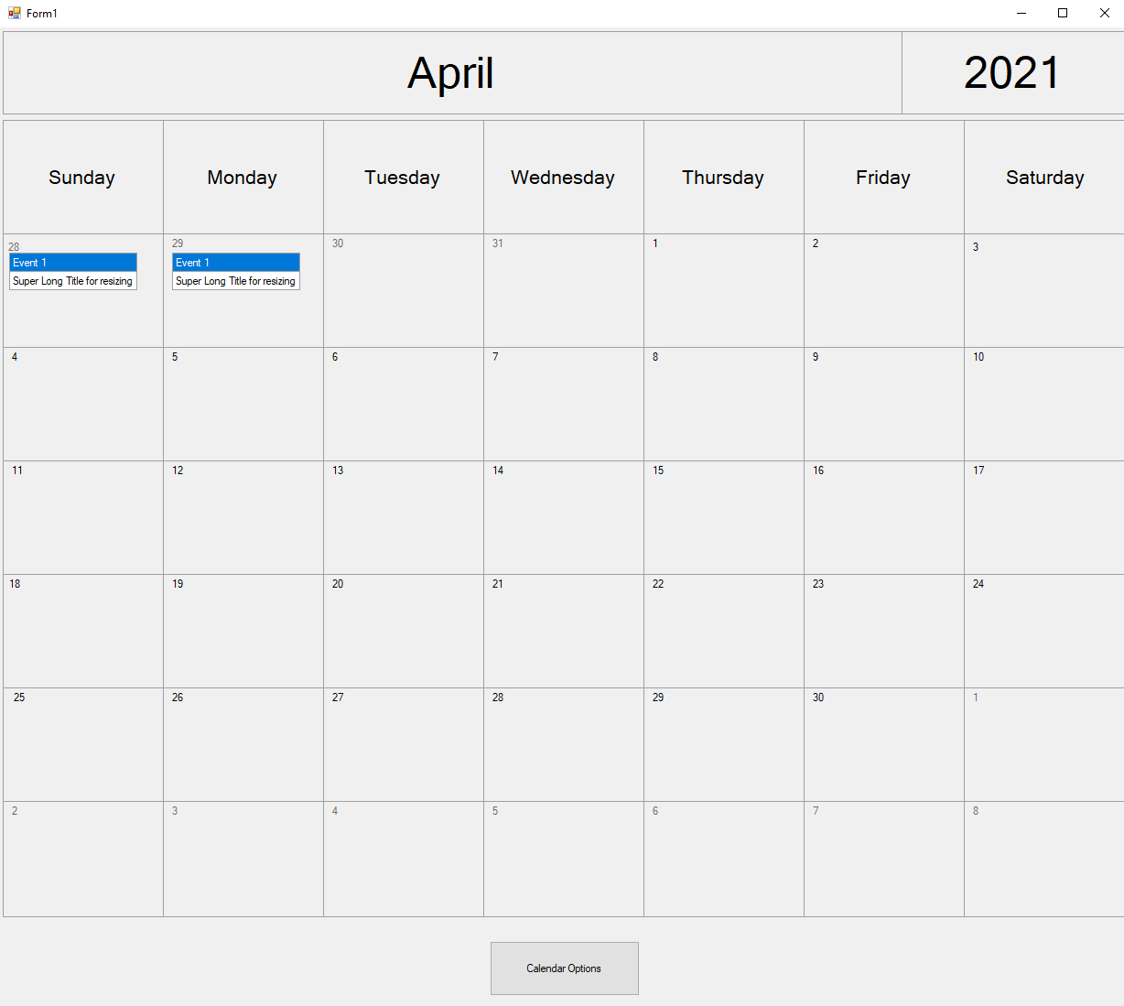

Figure Calendar Home Screen

* 1. The user shall select the “Calendar Options” to reveal the calendar options.
  2. The system will display the calendar event option menu the user may select from.
     1. The system will display the calendar event option “Add Event”.
     2. The system will display the calendar event option “Edit Event”.
     3. The system will display the calendar event option “Filter Calendar Event”.
     4. 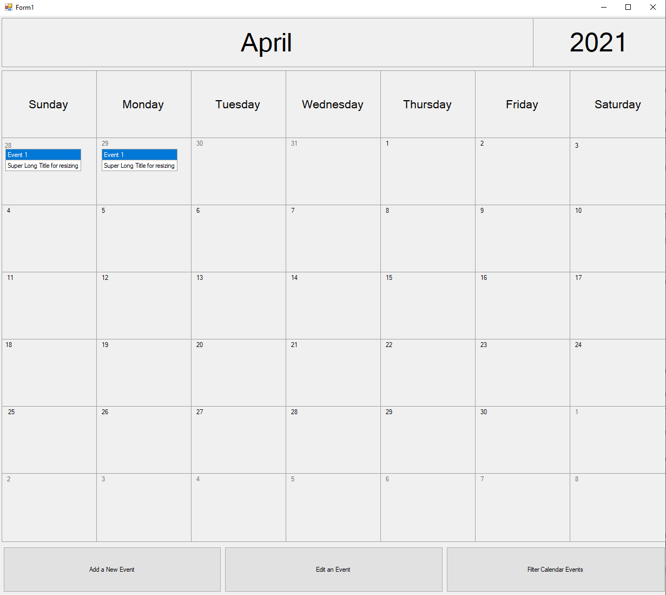

Figure Calendar User Options

* + - 1. If the user is a Manager the system shall display the calendar event option “Add a Team Event”
      2. If the user is a Manager the system shall display the calendar event option “Cancel a Team Event” 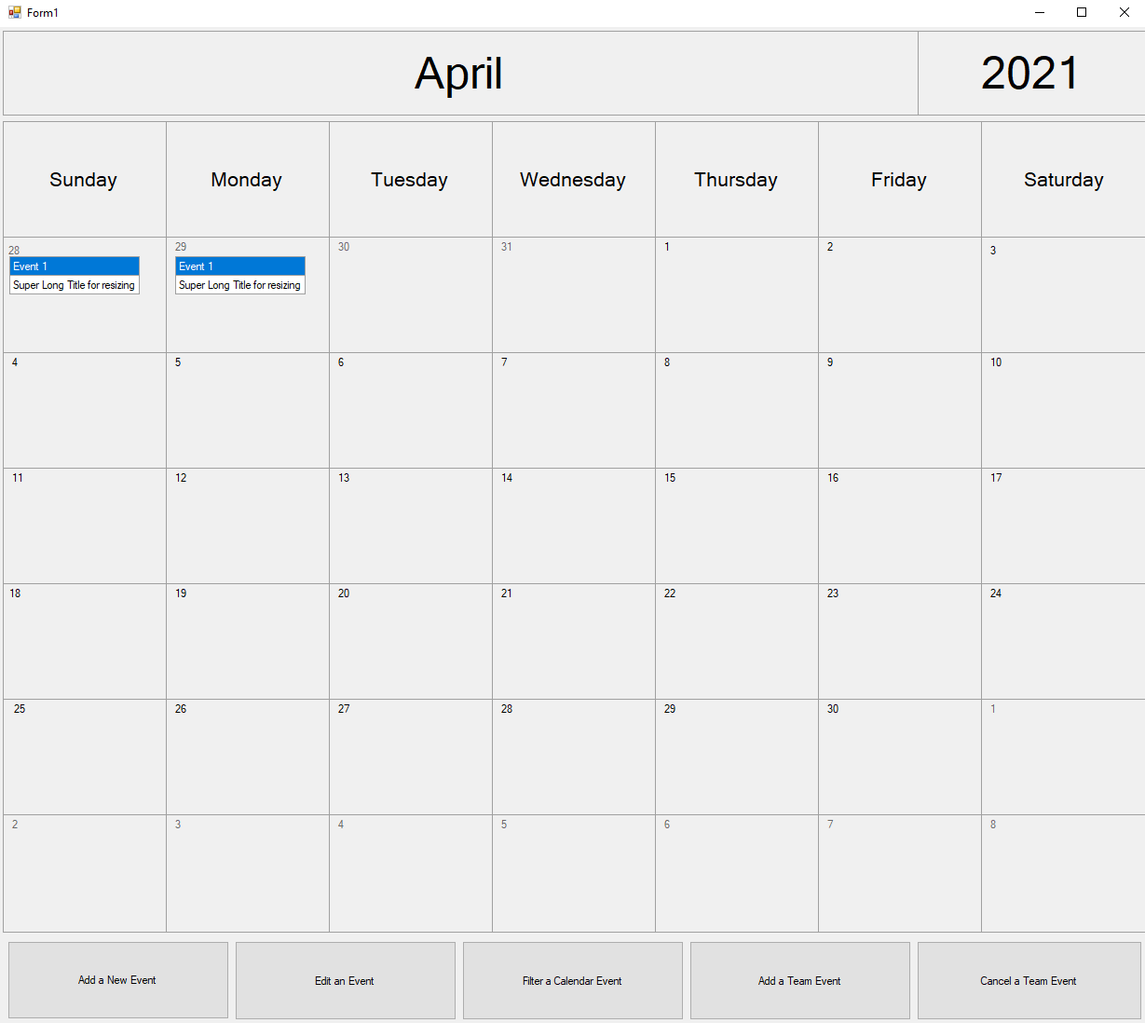

Figure Calendar Manager Options

* 1. The user will select the event option “Add Event”, to add an event to the calendar.
  2. The system will display a form where the user may input details of the added event.
     1. The user shall input details pertaining to the Date of the event.
     2. The user shall input details pertaining to the Title of the event.
     3. The user shall input details pertaining to the Start Time of the event.
     4. The user shall input details pertaining to the End Time of the event.
     5. The user may select to input details pertaining to include Notes of the event. 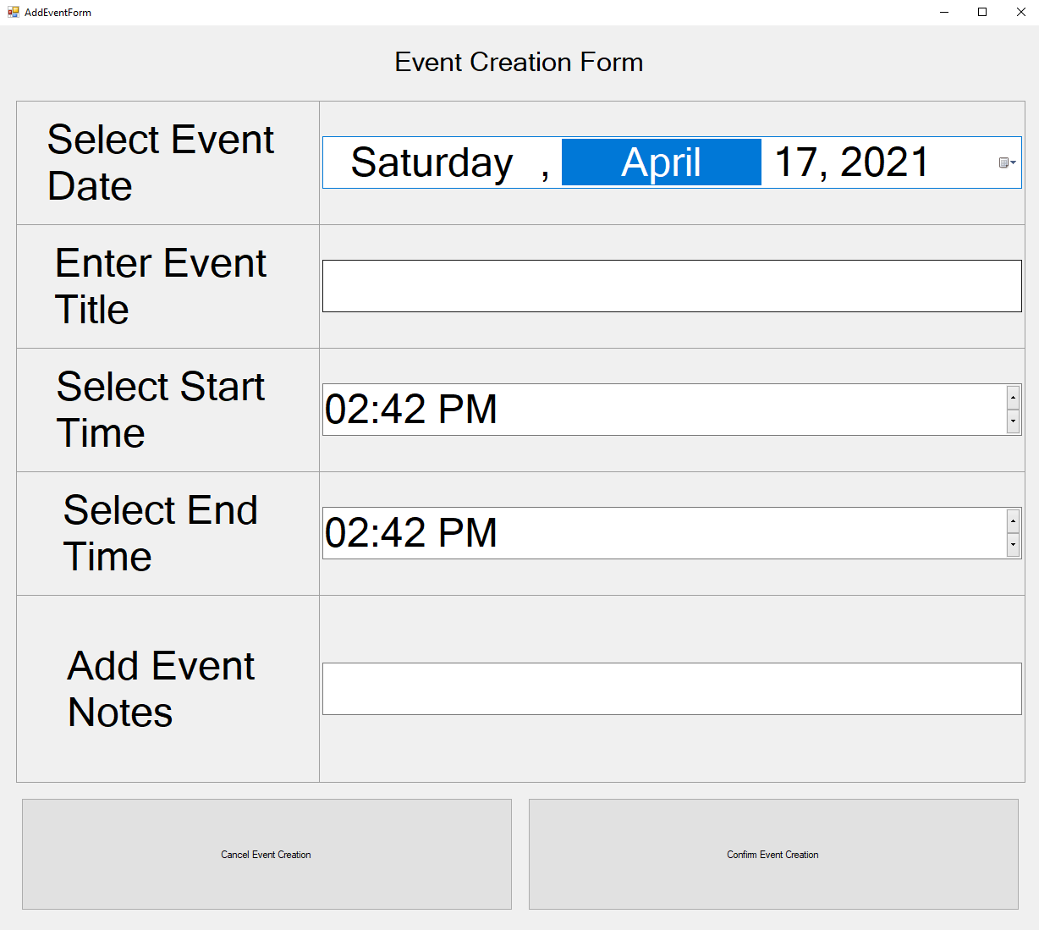

Figure Event Creation Form

* 1. The system will identify but allow for conflicts of events.
     1. The system shall allow the user to choose if the conflict is acceptable; by selecting “Yes” indicating that the user understands this event is conflicting but wishes to continue.
     2. The system shall allow the user to choose if the conflict is non-acceptable; by selecting “No” indicating that the user understands this event is conflicting but doesn’t wish to continue. 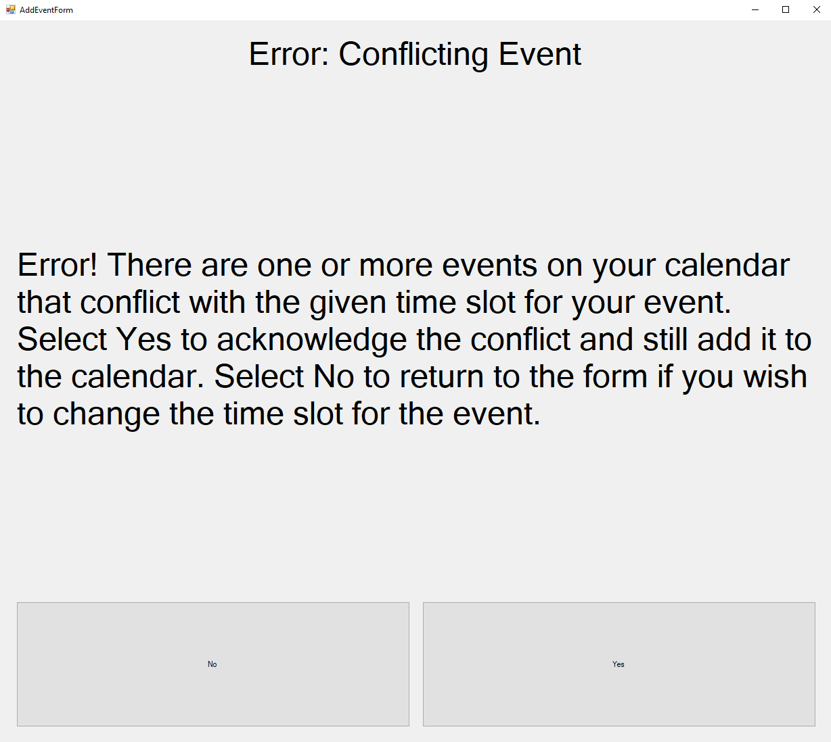

Figure Event Creation Conflicting Event

* 1. The system will display two buttons on the menu where the user shall select “Confirm” or “Cancel” for the event creation.
     1. The user may select the interactive button displaying “Save”, to save the event as well as adding the current event and its changes to the calendar.
     2. The user may select the interactive button displaying “Cancel”, to exit the event as well as deleting the current event and its changes to the calendar. 

Figure Event Creation Cancel Confirm Buttons

* 1. The system shall return the user to calendar display.
     + 1. The system will add any new events to the selected date, indicating the new changes the user implemented.
       2. The system will delete any new events to the selected date, indicating the new changes the user implemented.

1. The system shall allow a user to delete an event from **his/her** calendar.
   1. The system shall display all events to the user.
   2. The system shall display the events within a calendar format. 

Figure Calendar Home Screen

* 1. The user shall select an event in the calendar.
  2. The system shall display a description of the event.
     1. The system shall display the time of the event, the user/manager who created the event, any notes associated with the event, and a “Delete Event From Calendar” button at the bottom of the screen.

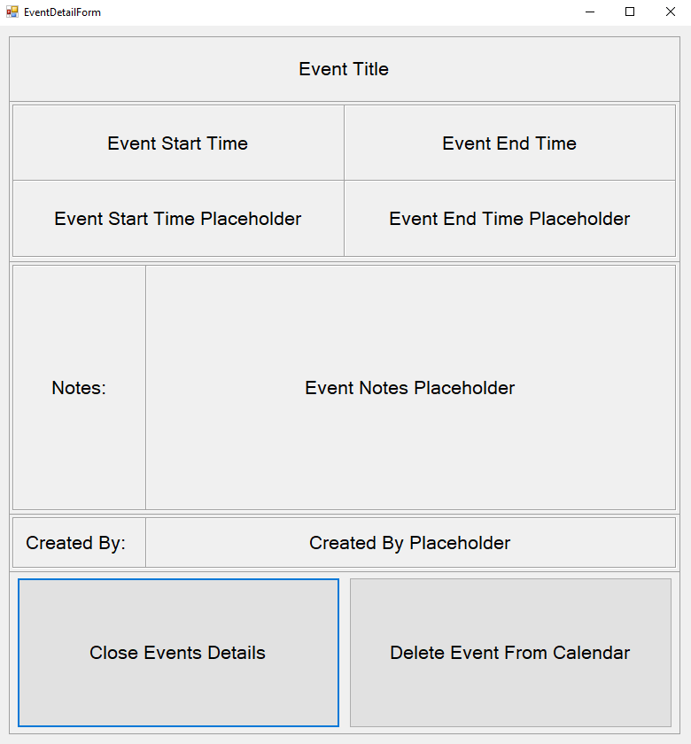

Figure Event Detail With Delete

* 1. The user shall select “Delete Event From Calendar” in the description menu. 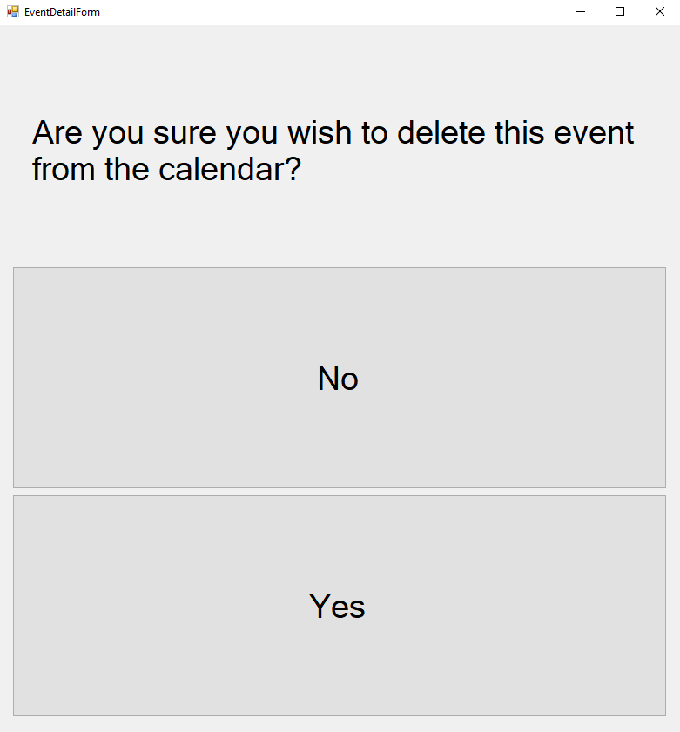

Figure Event Details Delete Confirmation

* 1. The system will verify that the user wishes to delete the event; “Yes” (to delete the event) “No” (to keep the event).
     1. The system shall delete the event if the user selects “Yes”.
     2. The system shall not delete the event if the user selects “No” and return to Step 2.4.
     3. The system shall return to the event calendar.

1. The system shall allow the user to edit an event to the calendar.
   1. The system will display a calendar option; upon selecting the button identified as “Calendar Options” at the bottom of the screen. 

Figure Calendar Home Screen

* 1. The user shall select the “Calendar Options” to reveal the calendar options.
  2. The system will display the calendar event option menu the user may select from.
     1. The system will display the calendar event option “Add Event”.
     2. The system will display the calendar event option “Edit Event”.
     3. The system will display the calendar event option “Filter Calendar Event”.



Figure Calendar User Options

* + - 1. If the user is a Manager the system shall display the calendar event option “Add a Team Event”
      2. If the user is a Manager the system shall display the calendar event option “Cancel a Team Event”



Figure Calendar Manger Options

* 1. The user will select the event option “Edit Event”, to change an event to the calendar.
  2. The system shall display a filterable list of events for the user to select from. 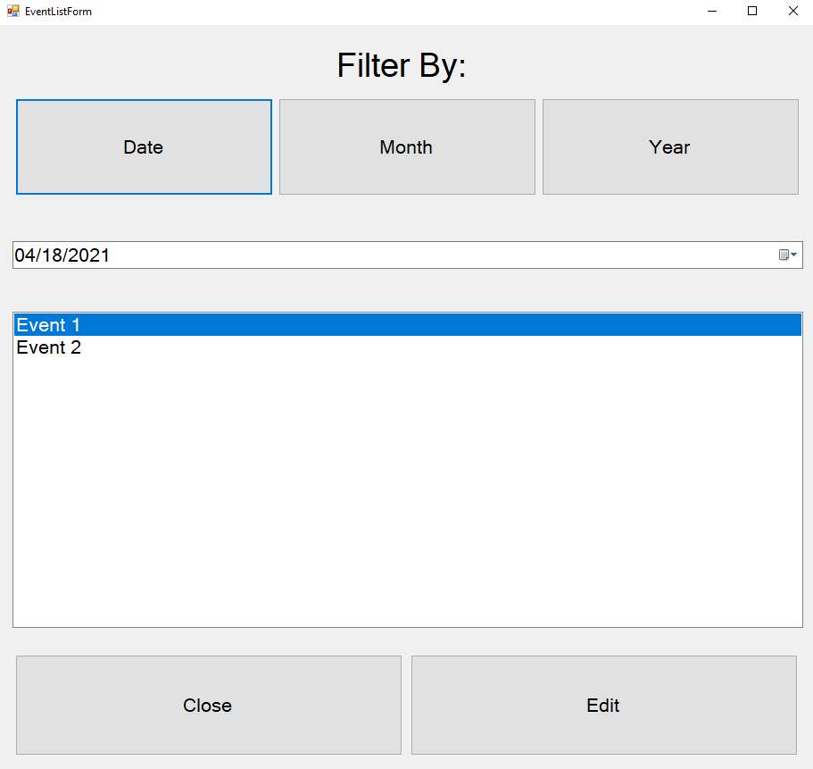

Figure Edit Event Details List

* + 1. If there are no events created by the user, the system shall display an error describing that there are no events available to edit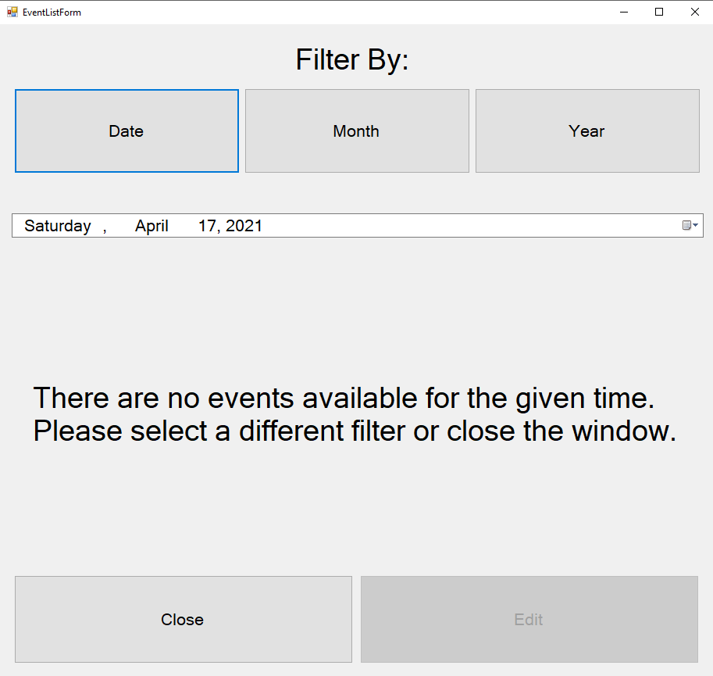

Figure No Event Available Error Message

* 1. The user shall select an event from the list
     1. The user may select a “Close” button to close the list and return 3.1
  2. The system will display a predetermined but interactive menu where the user may make changes to the previous input details of an added event.
     1. The user may select to change details pertaining to the Date of the event.
     2. The user may select to change details pertaining to the Title of the event.
     3. The user may select to change details pertaining to the Start Time of the event.
     4. The user may select to change details pertaining to the End Time of the event.
     5. The user may select to change details pertaining to the included Notes of the event.

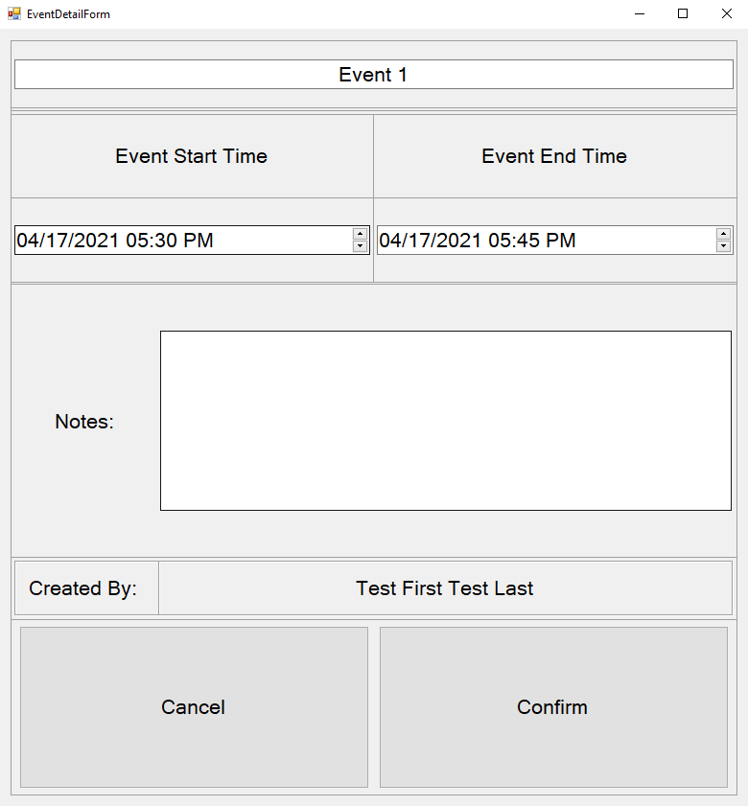

Figure Edit Event Details

* 1. The system will identify but allow for conflicts of events in the event of a Start or End Time Overlap.
     1. The system shall allow the user to choose if the conflict is acceptable; by selecting “Yes” indicating that the user understands this event is conflicting but wishes to continue.
     2. The system shall allow the user to choose if the conflict is non-acceptable; by selecting “No” indicating that the user understands this event is conflicting but doesn’t wish to continue.

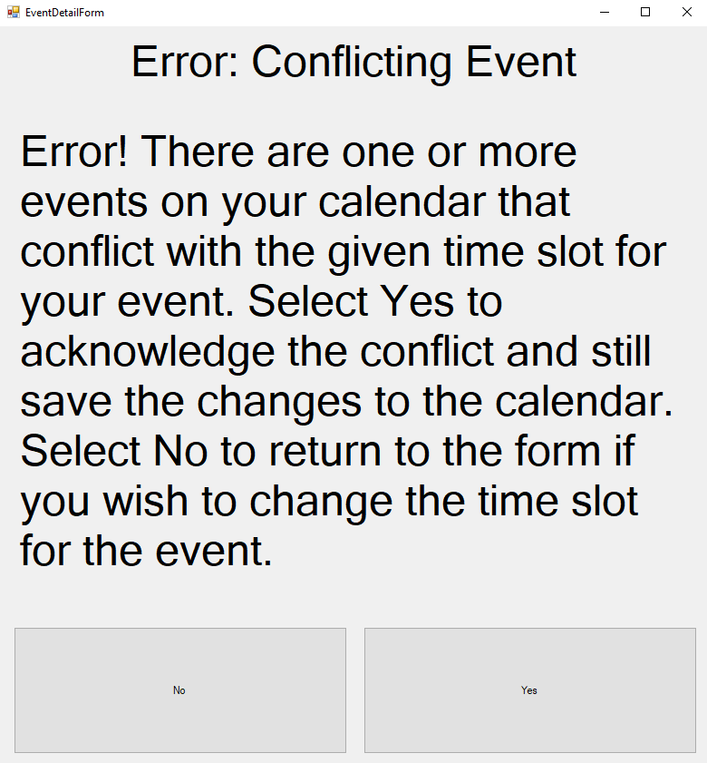

Figure Edit Event Conflict Error Message

* 1. The system will display two buttons on the menu where the user shall select “Confirm” or “Cancel” for the event modifications.
     1. The user may select the interactive button displaying “Confirm”, to save the event as well as adding the current event and its changes to the calendar.
     2. The user may select the interactive button displaying “Cancel”, to exit the event as well as deleting the current event and its changes to the calendar.



Figure Edit Event Cancel Confirm Buttons

* 1. The system shall return the user to calendar display.
     + 1. The system will add any new events to the selected date, indicating the new changes the user implemented.
       2. The system will delete any new events to the selected date, indicating the new changes the user implemented.

1. View an event functional requirement
   1. The simple calendar system display events that have been placed on the user calendar.

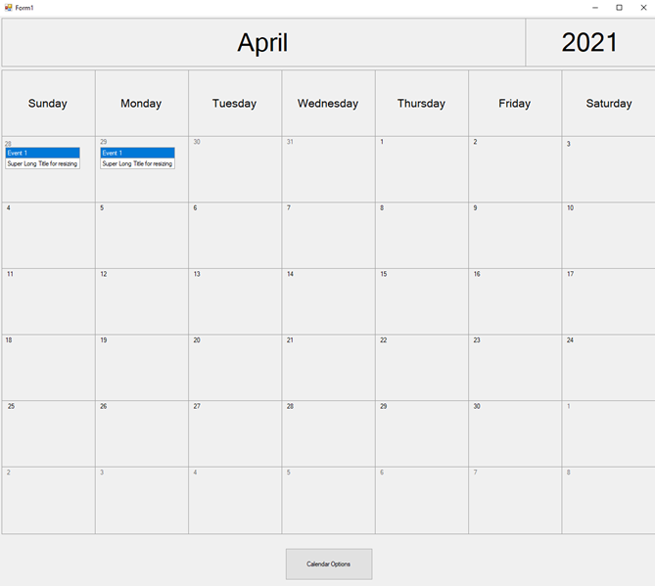

Figure Calendar Home Screen

* 1. The user will select an event.
  2. The simple calendar system shall display the event that the user selected.
  3. The simple calendar system shall have an exit button to allow for the user to exit the event view.



Figure Event Details Screen

* 1. The user shall click on the exit button and the simple calendar system will return the user to main calendar view.

1. The system shall allow a user to view **his/her** monthly based event list.
   1. The system shall display events to the user. 

Figure Calendar Home Screen

* 1. The user shall select “Event Options” within the event display.
  2. The system will display the calendar event option menu the user may select from.
     1. The system will display the calendar event option “Add Event”.
     2. The system will display the calendar event option “Edit Event”.
     3. The system will display the calendar event option “Filter Calendar Event”. 

Figure Calendar User Options

* + - 1. If the user is a Manager the system shall display the calendar event option “Add a Team Event”
      2. If the user is a Manager the system shall display the calendar event option “Cancel a Team Event” 

Figure Calendar Manager Options

* 1. The user shall select “Filter Calendar Event” in the event menu.
  2. The system shall display the filter options.
     1. The system shall filter based on day, month, and year. 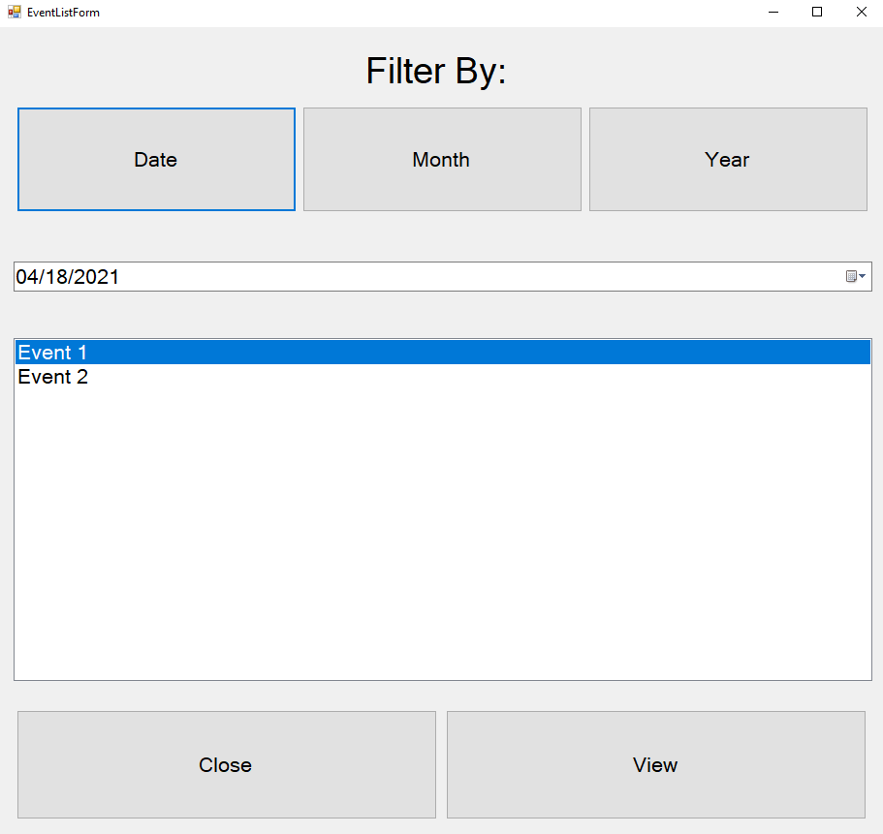

Figure Event Filter Options

* 1. The user shall select “Monthly” in the event menu.
  2. The system shall filter the events by month of the current year.
  3. The system shall update the list of events.
  4. The system shall display the updated filtered calendar in list format.

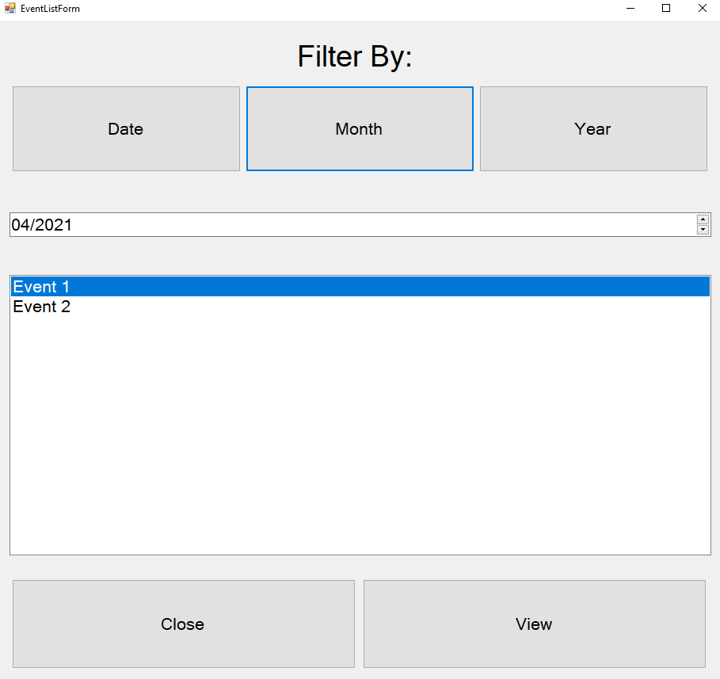

Figure Event List by Month/Year

1. The system shall allow a manager to coordinate a meeting for his/her teammates.
   1. The system will display a calendar option; upon selecting the button identified as “Calendar Options” at the bottom of the screen. 

Figure Calendar Home Screen

* 1. The user shall select the “Calendar Options” to reveal the calendar options.
  2. The system will display the calendar event option menu the user may select from.
     1. The system will display the calendar event option “Add Event”.
     2. The system will display the calendar event option “Edit Event”.
     3. The system will display the calendar event option “Filter Calendar Event”. 

Figure Calendar User Options

* + - 1. If the user is a Manager the system shall display the calendar event option “Add a Team Event”
      2. If the user is a Manager the system shall display the calendar event option “Cancel a Team Event” 

Figure Calendar Manager Options

* 1. The manager shall select “Add a Team Event”.
  2. The system shall display a form containing fields for preferred meeting date, meeting duration, meeting members, and an option to allow outside of business hours (NF1).
     1. The system shall retrieve a list of teammates associated with the given manager from the database.

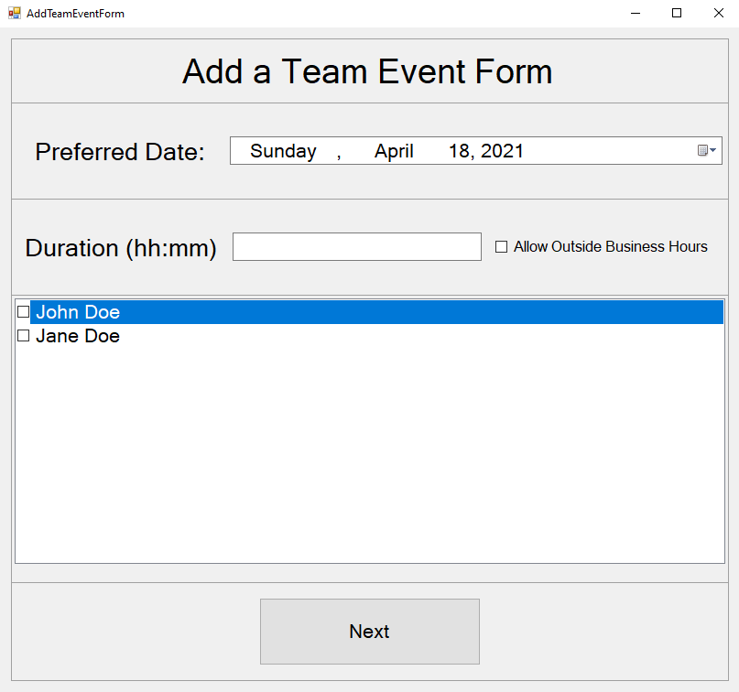

Figure Team Event Creation Form

* 1. The manager shall select “Next” after completing all form fields.
     1. If the from is not completed, the “Next” button shall be disabled and indicate the form is incomplete.

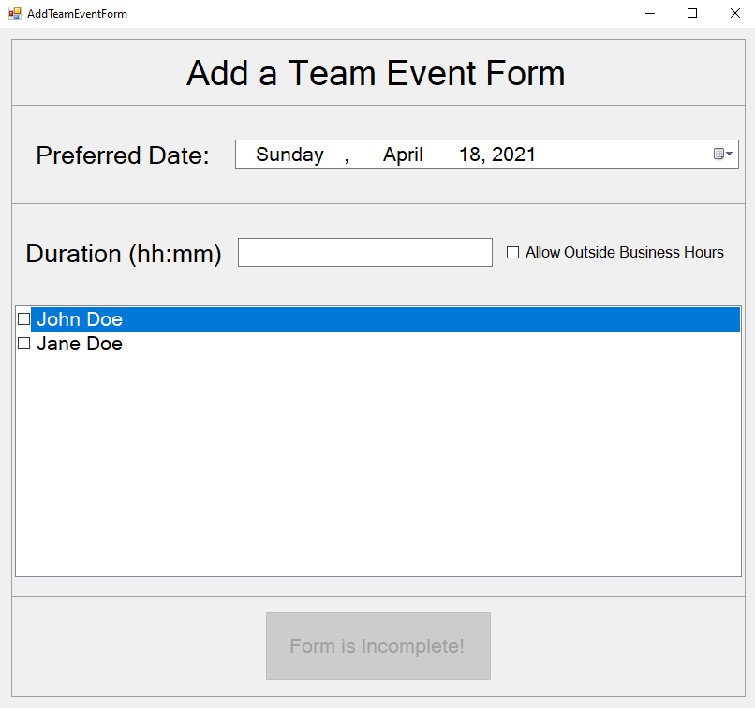

Figure Add Team Event Incomplete Form

* 1. The system shall retrieve all non-past events for each teammate and manager.
     1. The system shall sort the list of conflicting events by date-time
  2. The system shall compare the list of events to create a list of possible time slots that the team could meet.
     1. If no such time slots exist, the system shall display an error message with option to “Return to Team Event Form” screen.

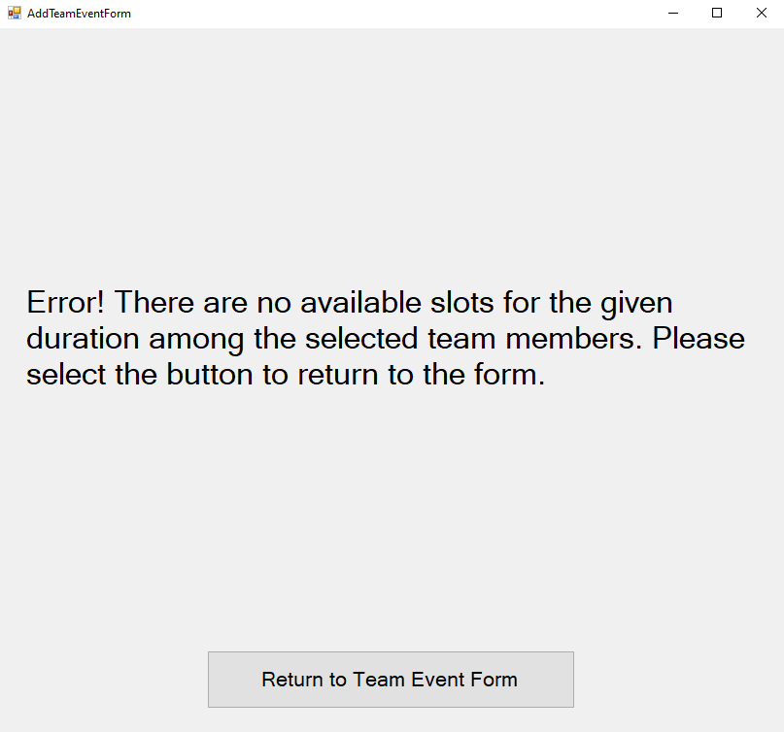

Figure No Available Slots Error

* + 1. If one or more time slots exist, the system shall format the slots in list form, sorted in ascending date-time.
  1. The system shall display a selectable list of available slots along with a confirmation button to the manager.

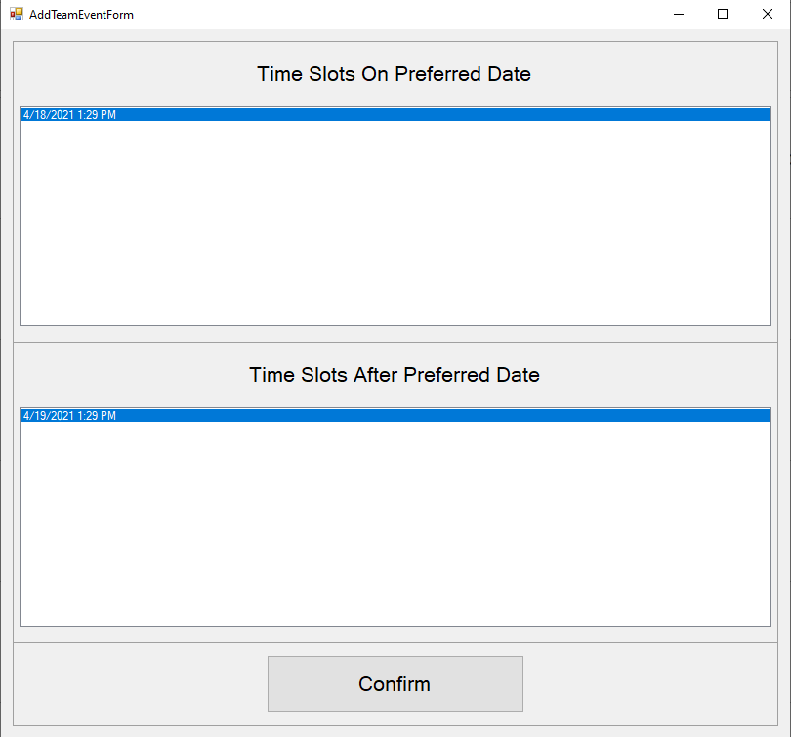

Figure Add Team Event Available Time Slots

* + 1. If no slot is selected, the “Confirm” button shall be disabled and read “No Time Slot Selected”

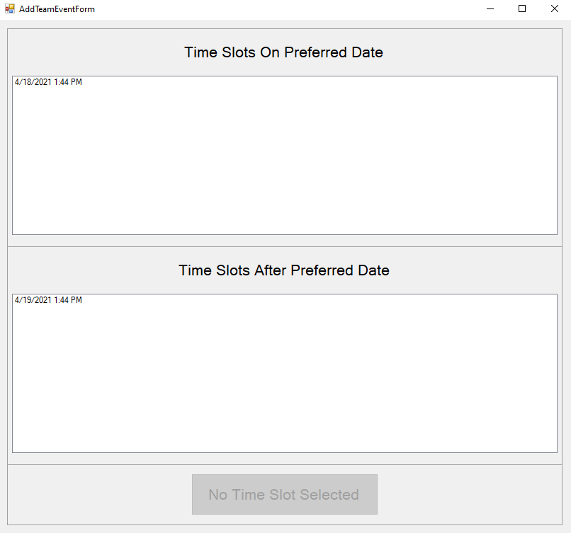

Figure No Time Slot Selected

* 1. The system shall use the selected time, duration, and the Ids of teammates/managers to open the new event creation form from R1.5 through R1.7.
  2. Upon completion of 6.10, the system shall push the created event to each selected members’ calendar.

1. Extra service manager can cancel meeting
   1. The simple calendar system shall display a “Calendar Options” button



Figure Calendar Home Screen

* 1. The user shall select “Event Options” within the event display.
  2. The system will display the calendar event option menu the user may select from.
     1. The system will display the calendar event option “Add Event”.
     2. The system will display the calendar event option “Edit Event”.
     3. The system will display the calendar event option “Filter Calendar Event”.



Figure Calendar User Options

* + - 1. If the user is a Manager the system shall display the calendar event option “Add a Team Event”
      2. If the user is a Manager the system shall display the calendar event option “Cancel a Team Event”



Figure Calendar Manager Option

* 1. The manager shall select the “Cancel a Team Event” option.
  2. The simple calendar system shall display a list of meetings that the manager created.



Figure Filtered Event List Manger

* + 1. If there are no meetings to display, the system shall display an error and return to 7.1

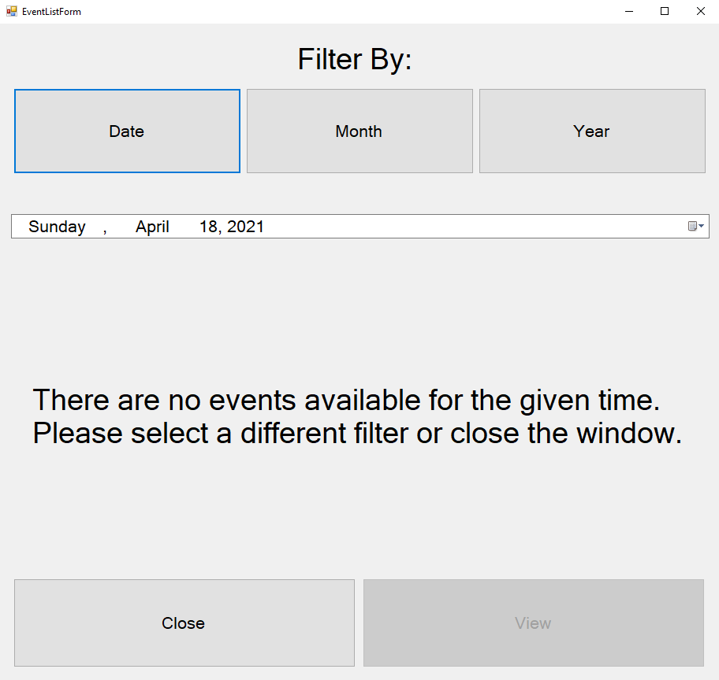

Figure Cancel Team Meeting No Events Available Error

* 1. The Manager shall select the meeting they wish to cancel.
  2. The simple calendar system shall display a warning message “Are you sure you wish to delete this event from the calendar?”



Figure Delete Event Manager Confirmation

* 1. If the manager clicks yes to continue the simple calendar system shall delete the meeting event and return the manager to the main calendar of events.
  2. If the manager clicks no the simple calendar system shall return the manager to step 7.3

Non-Functional Requirements:

1. The calendar format shall be separated by year, then by month, then by day. The calendar format shall start each week on Sunday and end each week on Saturday. The calendar will leave days null if the month does not end on a Saturday.
2. The system shall only find possible available time slots within acceptable business hours (7AM – 8PM) without manager override.